# **Superconductor Stuff**

Adiabatic Quantum-Flux-Parametron (AQFP) logic is an adiabatic superconductor logic family that has been proposed as a future technology for building extremely energy-efficient computing systems. Dynamic energy dissipation can be drastically reduced by following the adiabatic switching operations using AC excitation currents.

Unlike traditional [CMOS](https://en.wikipedia.org/wiki/CMOS) circuits, which [dissipate energy](https://en.wikipedia.org/wiki/Dissipation) during switching, adiabatic circuits reduce dissipation by following two key rules:

* Never turn on a transistor when there is a voltage potential between the source and drain.
* Never turn off a transistor when current is flowing through it.

Because of the second law of thermodynamics, it is not possible to completely convert energy into useful work. However, the term "adiabatic logic" is used to describe logic families that could theoretically operate without losses.

As a result of this AQFP could overcome the limitation in conventional superconductors such as RSFQ’s. Simulation and experimental results show that AQFP logic can achieve an energy-delay-product (EDP) near the quantum limit using practical circuit parameters and available fabrication processes.

Quantum limit - restriction on measurement due to quantum effects,

Power Delay Product (PDP) is the energy dissipated in a circuit per switching operation.

Energy delay Product (EDP) is a value being the product of the total energy consumption of the cores and the delay in the time for executing applications.

The major advantage of AQFP is the remarkable energy efficiency potential. A latest work[10](https://www.nature.com/articles/s41598-019-46595-w#ref-CR10) analyzed the energy dissipation of an 8-bit AQFP adder and reported a 24*kBT* energy dissipation per junction based on the physical test. This number indicates that AQFP technology is a promising candidate to build low-energy systems approaching Landauder’s limit[11](https://www.nature.com/articles/s41598-019-46595-w#ref-CR11),[12](https://www.nature.com/articles/s41598-019-46595-w#ref-CR12),[13](https://www.nature.com/articles/s41598-019-46595-w#ref-CR13),[14](https://www.nature.com/articles/s41598-019-46595-w#ref-CR14).

This is the article where all this is coming from.

https://www.nature.com/articles/s41598-019-46595-w

**Other stuff important**

JoSIM was developed under IARPA contract SuperTools(via the U.S. Army Research Office grant W911NF-17-1-0120). JoSIM is a analogue circuit simulator with SPICE syntax input that has inherent support for the superconducting Josephson junction element.

RSFQ-based logic circuits can operate at high clock frequency of hundreds of GigaHertz with very low switching energy on the superconducting devices in the order of 10−19 J. However, on-chip resistors are needed to supply a constant DC bias current to the main RSFQ circuit. This will lead to an increasing static power as the circuit scale expands, and makes power dissipation a disadvantage of RSFQ.

At room temperature, the Landauer limit represents an energy of approximately 0.018 eV (2.9×10−21 J). Modern computers use about a billion times as much energy per operation.

MAJ (Majority Gate) outputs high when majority of its signals are high.

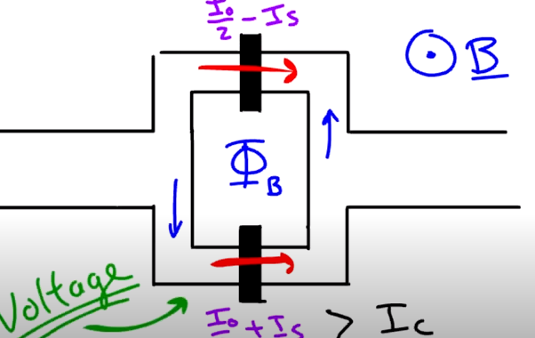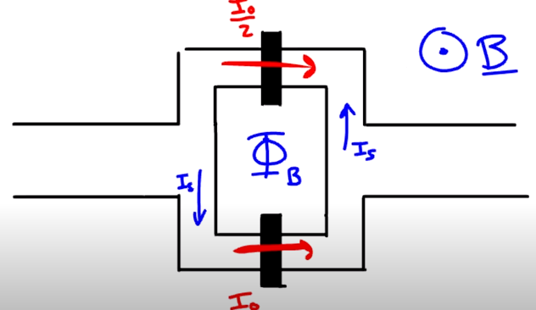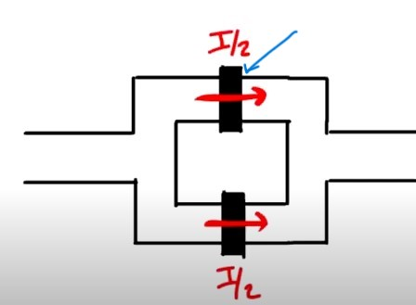Blue arrow indicates the Josephson junction, which is just a break in the superconductor to slightly increase resistance. The entire diagram is called a SQuID

External magnetic field is applied to induce a small current known as screening current which effects the current in the two branches as shown above.

**New Info Gathered**

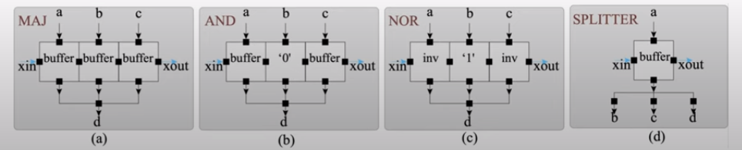Basic logic structure of an AQFP logic is a buffer. Uses two Josephson junctions. May be the green elements shown? Using this AQFP buffer we can create different logic cells as shown below.

AQFP logic gates are driven by AC clock which synchronises the gate outputs.

Below is a diagram showing how a full adder can be made using AND, buffers and splitter logic shown previously.

Requires 102 Josephson junctions

Only requires 34 Josephson junctions

Youtube: <https://youtu.be/j_87dJAqPSc>

Website: in downloads

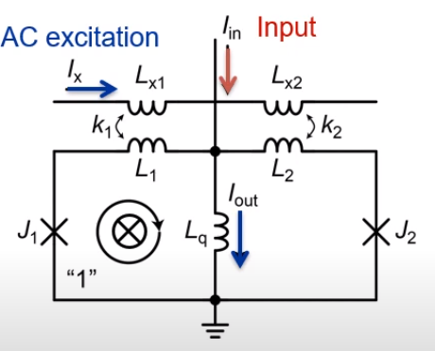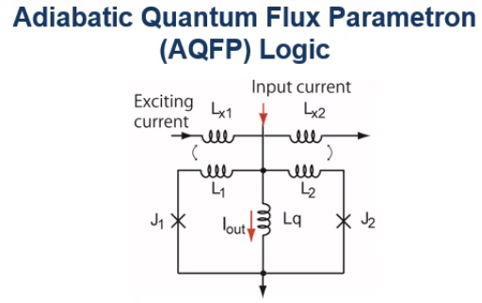Second video showing AQFP logic: <https://youtu.be/H8OxcBAzgto>

As shown in the diagram on the right an input current is applied first. Then an AC excitation current is applied by which the left Josephson junction is switched and Single flux Qanta (SFQ) is entered into the left Josephson junction. This results in a large downward output current.

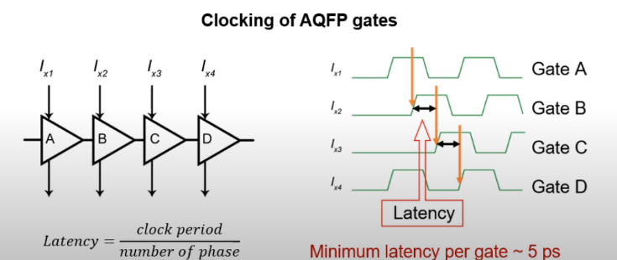When the input current Is reversed the right Josephson junction switches. This results in a large upward output current.

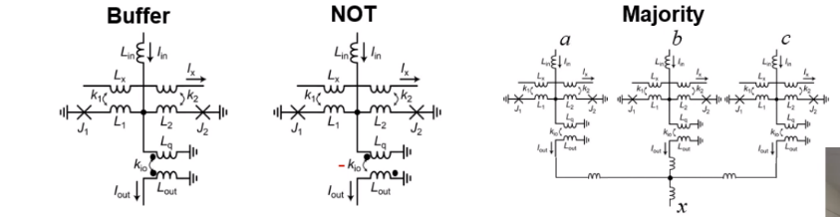Every AQFP has to be clocked by excitation current.

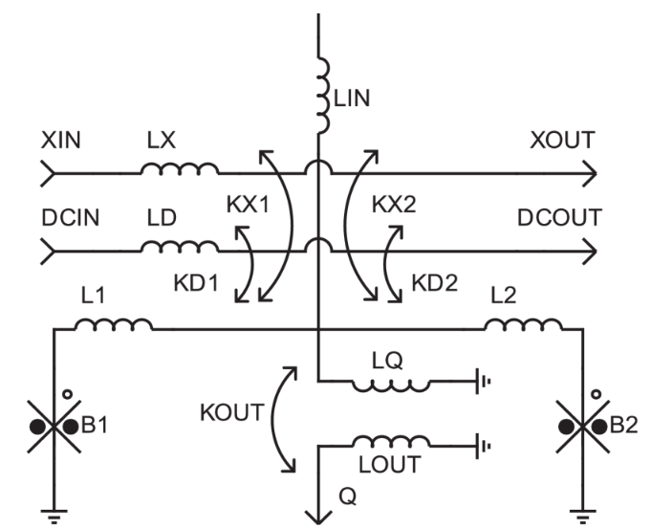AQFP cell layout shown at 10:41 something

<https://arxiv.org/abs/2307.12008>

Room temperature and ambient pressure super conductor.

**This is why the circuits are considered adiabatic.**

In the 2000s, energy became the key limiter of computer performance [40]–[42], and energy efficiency has been the most important metric in computer design. Also, the increasing power demand for ICT indicates the need for low-power computing, as mentioned in the introduction. Therefore, we revived the QFP and proposed an energyefficient QFP, the AQFP [5], which is designed to maximize the energy efficiency of adiabatic switching by using optimized circuit parameters and advanced fabrication processes. We have established the design methodology for AQFP logic and recently succeeded in demonstrating a 4-bit microprocessor [10]. We have also developed various systems by exploiting the physical features of the AQFP, such as reversible computers[43], [44], single-photon image sensors[45], [46], and stochastic electronics[47], [48]. This indicates the potential of AQFP logic to be widely used in future ICT.

**3. Operating Principle**

This section describes the operating principle of the QFP and AQFP, focusing on potential energy and adiabatic switching. We begin by deriving the potential energy of an rf SQUID, since the QFP and AQFP are based on an rf SQUID. We then derive the potential energy of the QFP and show that the QFP can perform adiabatic switching, i.e., the potential energy shape of the QFP changes gradually from a single well to a double well. Lastly, we explore the energy dissipation for adiabatic switching and show that AQFP logic operates with energy dissipation near the thermodynamic and quantum limits by maximizing the energy efficiency of adiabatic switching.

Design of the AQFP is on the VeryHelpfulAQFPfile on page 255 full design of gates, logic and AQFP circuits.

**Stuff Prof Fourie has given me**

<https://github.com/JoeyDelp/JoSIM>

<https://ieeexplore-ieee-org.ez.sun.ac.za/search/searchresult.jsp?newsearch=true&queryText=AQFP>